Практическая работа 9

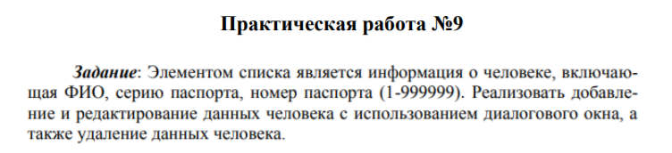

1. Form1

1.1 Внешний вид

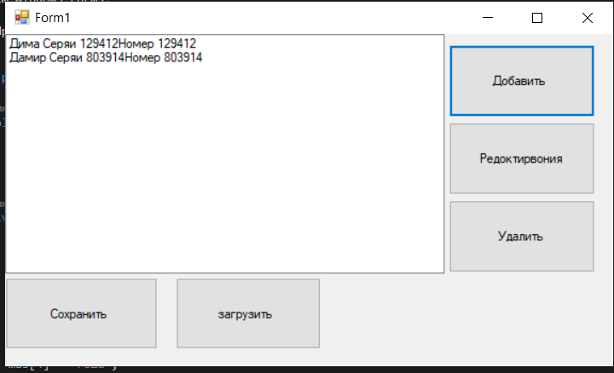

1.2 Код

using System;

using System.Collections.Generic;

using System.ComponentModel;

using System.Data;

using System.Drawing;

using System.Linq;

using System.Text;

using System.Threading.Tasks;

using System.Windows.Forms;

using System.IO;

namespace Практичсекая_рабоа_9_v2

{

public partial class Form1 : Form

{

public Form1()

{

InitializeComponent();

}

private void button1_Click(object sender, EventArgs e)

{

Form2 f = new Form2();

if (f.ShowDialog() == DialogResult.OK)

{

people p = new people();

p.FIO = f.textBox1.Text;

p.S = Convert.ToInt32(f.textBox2.Text);

p.N = Convert.ToInt32(f.textBox2.Text);

listBox1.Items.Add(p);

}

}

private void button2_Click(object sender, EventArgs e)

{

Form3 f = new Form3();

if (listBox1.SelectedIndex == -1)

{

MessageBox.Show("Не выбран объект для редоктиования");

}

else

{

int k = listBox1.SelectedIndex;

people p = listBox1.Items[k] as people;

f.textBox1.Text = p.FIO;

f.textBox2.Text = Convert.ToString(p.S);

f.textBox3.Text = Convert.ToString(p.N);

if (f.ShowDialog() == DialogResult.OK)

{

p.FIO = f.textBox1.Text;

p.S = Convert.ToInt32(f.textBox2.Text);

p.N = Convert.ToInt32(f.textBox3.Text);

listBox1.Items[k] = p;

}

}

}

private void button3_Click(object sender, EventArgs e)

{

Form4 f = new Form4();

if (f.ShowDialog() == DialogResult.OK)

{

if (listBox1.SelectedIndex == -1)

{

MessageBox.Show("Выберите элемент для удаления");

}

else

{

int k = listBox1.SelectedIndex;

listBox1.Items.RemoveAt(k);

if (listBox1.SelectedIndex == 0)

{

}

}

}

}

private void Form1_Load(object sender, EventArgs e)

{

}

private void button4_Click(object sender, EventArgs e)

{

if (saveFileDialog1.ShowDialog() == DialogResult.OK)

{

StreamWriter sw = new StreamWriter(saveFileDialog1.FileName);

for(int i = 0; i < listBox1.Items.Count; i++)

{

people p = listBox1.Items[i] as people;

sw.WriteLine(p.FIO);

sw.WriteLine(p.S);

sw.WriteLine(p.N);

}

sw.Close();

}

}

private void button5_Click(object sender, EventArgs e)

{

if (openFileDialog1.ShowDialog() == DialogResult.OK)

{

StreamReader sr = new StreamReader(saveFileDialog1.FileName, System.Text.Encoding.Default);

while (!sr.EndOfStream)

{

people p = new people();

p.FIO = sr.ReadLine();

p.S = Convert.ToInt32(sr.ReadLine());

p.N = Convert.ToInt32(sr.ReadLine());

listBox1.Items.Add(p);

}

sr.Close();

}

}

}

}

2. Form2

2.1 Внешний вид

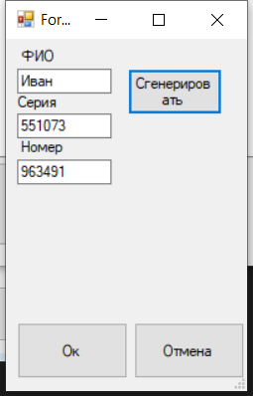

2.2 Код

using System;

using System.Collections.Generic;

using System.ComponentModel;

using System.Data;

using System.Drawing;

using System.Linq;

using System.Text;

using System.Threading.Tasks;

using System.Windows.Forms;

namespace Практичсекая_рабоа_9_v2

{

public partial class Form2 : Form

{

public Form2()

{

InitializeComponent();

}

private void button1_Click(object sender, EventArgs e)

{

string[] mas = new string[6];

Random r1 = new Random();

Random r = new Random();

mas[0] = "Егор";

mas[1] = "Дима";

mas[2] = "Дамир";

mas[3] = "Арсений";

mas[4] = "Гоша";

mas[5] = "Иван";

textBox1.Text=(mas[r.Next(0, 6)]);

textBox2.Text = Convert.ToString(r.Next(1, 1000000));

textBox3.Text = Convert.ToString(r1.Next(1, 1000000));

}

private void Form2_FormClosing(object sender, FormClosingEventArgs e)

{

int k = 0;

try

{

if (textBox1.Text == "")

{

throw new Exception("Вы не ввели ФИО");

}

int r = Convert.ToInt32(textBox2.Text);

k++;

double t = Convert.ToDouble(textBox3.Text);

}

catch(FormatException)

{

if (k == 0)

{

MessageBox.Show("Вы не ввели серию паспорта");

textBox2.Focus();

}

else if (k == 1)

{

MessageBox.Show("Вы не ввели номер паспорта");

textBox3.Focus();

}

e.Cancel = true;

}

catch(Exception E)

{

MessageBox.Show(E.Message);

textBox1.Focus();

e.Cancel= true;

}

}

private void Form2_Load(object sender, EventArgs e)

{

}

}

}

3. Form3

3.1 Внешний вид

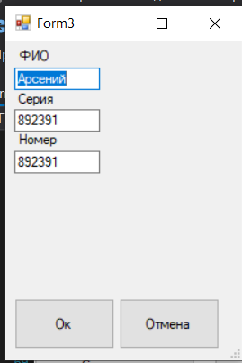

4. Form4

4.1 Внешний вид

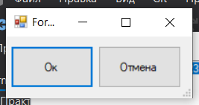

5. GitHub

<https://github.com/RgorkaK9/-9.git>